Bahria University,

Karachi Campus



LAB EXPERIMENT NO.

4

LIST OF TASKS

|  |  |
| --- | --- |
| TASK NO | OBJECTIVE |
| 1 | Develop an employee profile within the MVC .NET web application. Design a user interface that allows users to view, create, update, and delete employee records using ADO .Net Entity Framework. |
| 2 | Implement a product catalog in the MVC .NET web application utilizing ADO.NET Entity Framework. Design a user interface that enables users to browse, add, modify, and remove product records |
|  |  |
|  |  |
|  |  |
|  |  |
|  |  |
|  |  |
|  |  |
|  |  |

Submitted On:

**___________**

Task 01: Develop an employee profile within the MVC .NET web application. Design a user interface that allows users to view, create, update, and delete employee records using ADO .Net Entity Framework.

Solution:

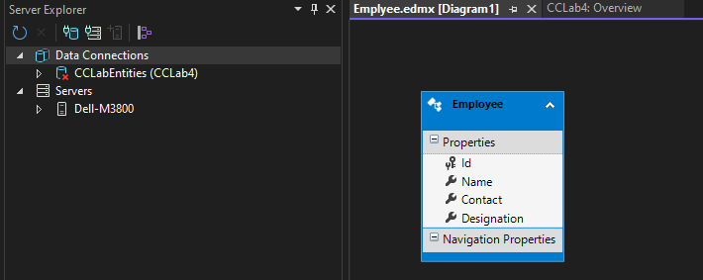

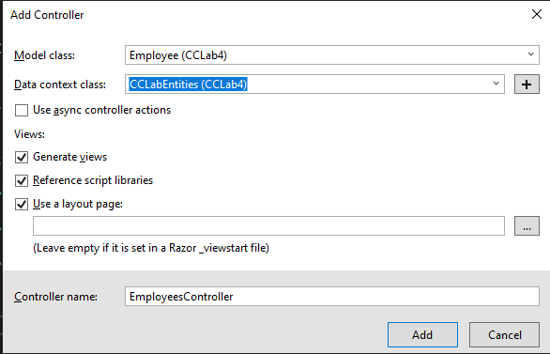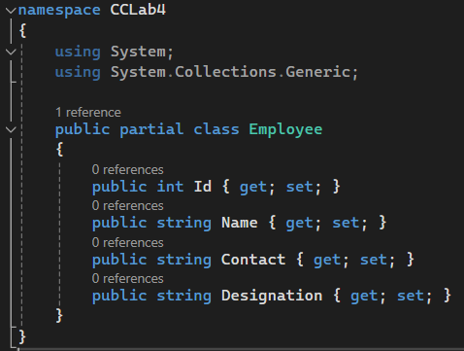

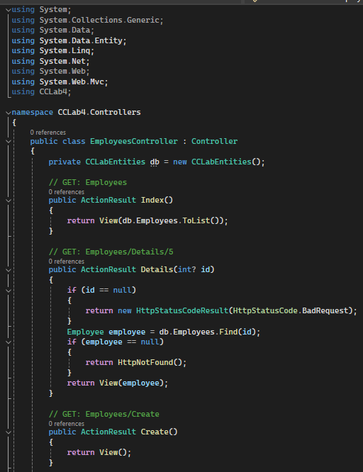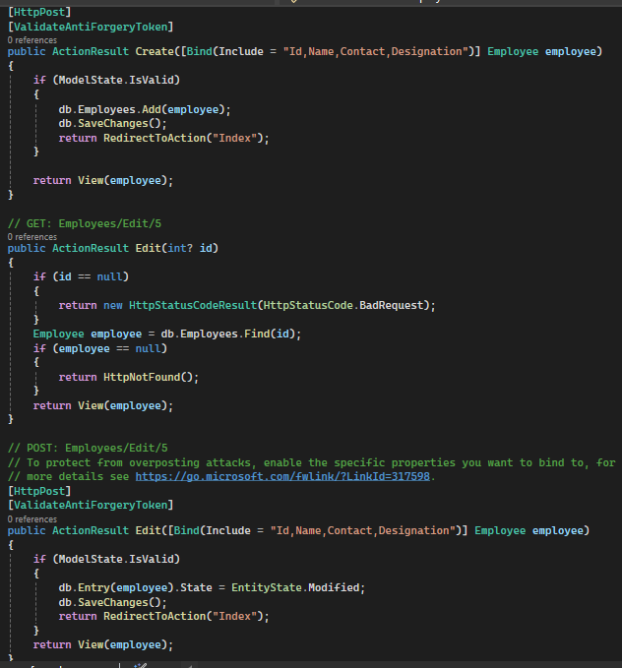

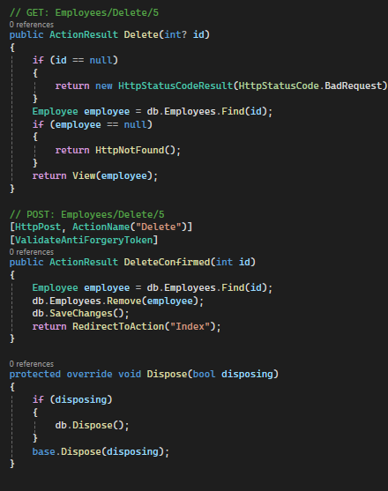

Output:

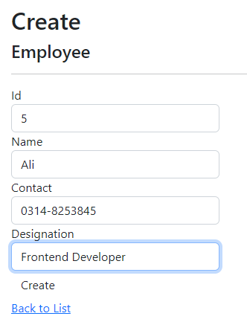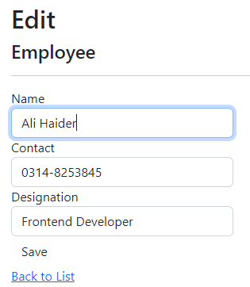

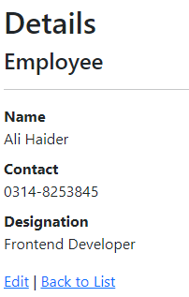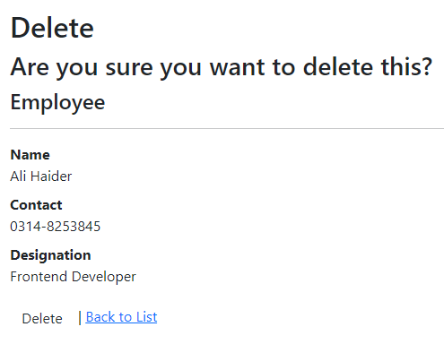

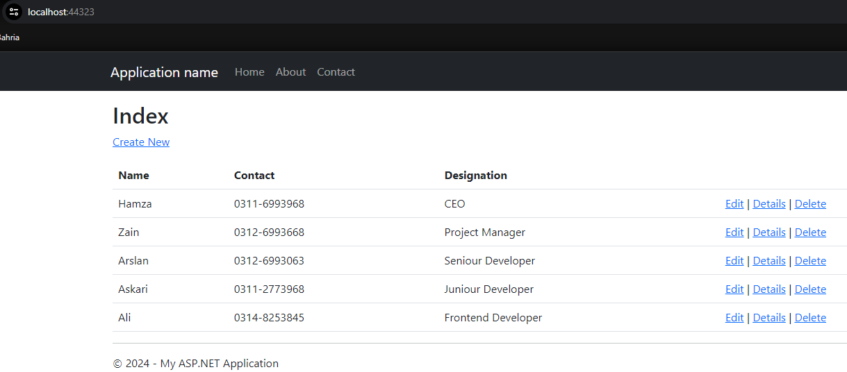

Task 02: Implement a product catalog in the MVC .NET web application utilizing ADO.NET Entity Framework. Design a user interface that enables users to browse, add, modify, and remove product records

Solution:

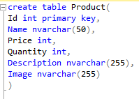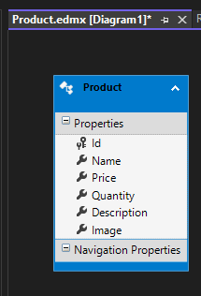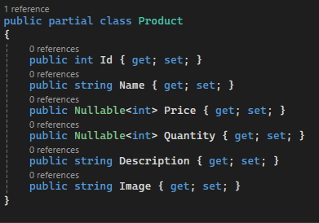

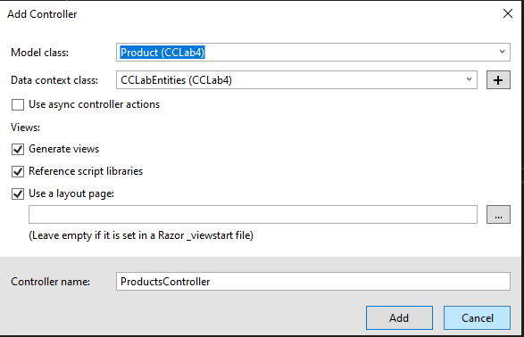

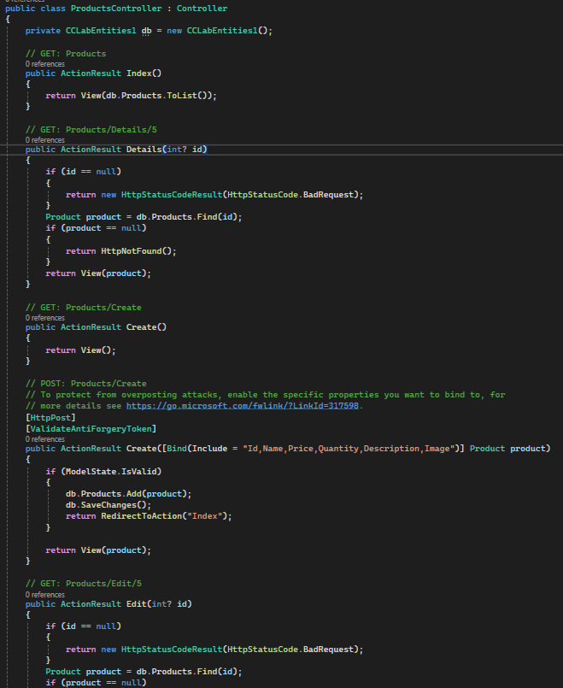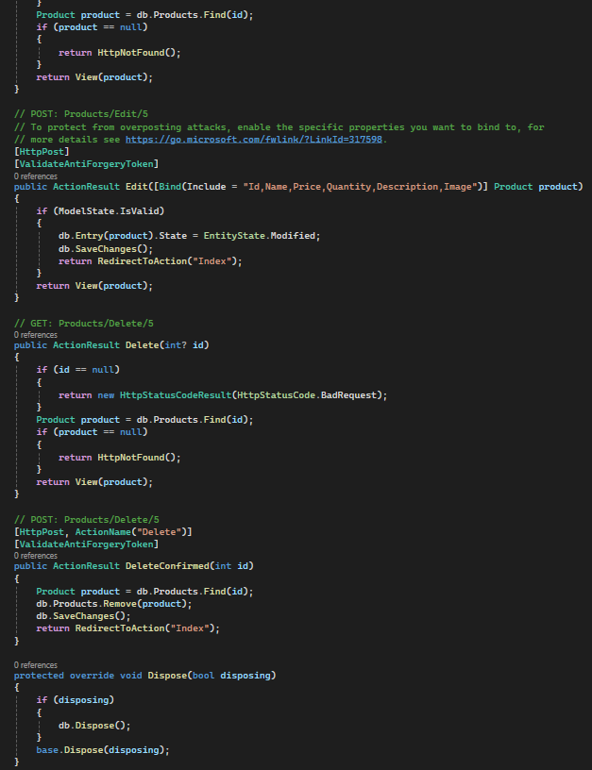

Output:

